**SCM 651 Fall 2017: Microsoft Excel Basics**

**(Based on notes by Professor Harter)**

* Go to the Course Website on BlackBoard. In Content 🡺 Class Sessions 🡺 Material for Sessions 1 and 2, save to your desktop “Excel Data for Sessions 1 and 2.xlsx”

**Data Entry**

* The spreadsheet is formatted as columns (A, B, C…) and rows (1, 2, 3 …). The column labels are across the top; the row labels are down the left side.
* To type in data, click on the cell A1 and begin entering data. Use the tab key to move to the next cell. Use your mouse to click on any particular cell. Enter the data listed below.

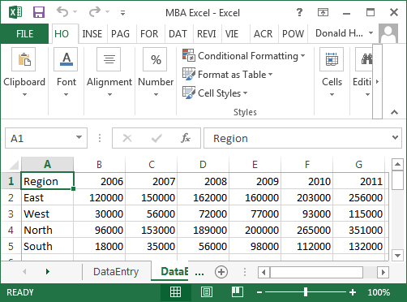

### To change the format of a cell, click on the cell and use the buttons in the Font section.

* + Change the first line to Bold and center
  + Change the regions to Italics
  + Use the comma (,) button to add commas to the sales, then reduce the number of zeros with the .00 -> .0 button

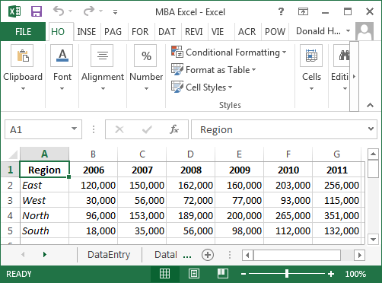

### To enter a new row before the first row, click on the 1 in the left column, which will highlight the first row

* Use the drop down arrow next to Insert, and insert sheet rows. Insert two rows before the first row.
* In the new cell A1, type in Blue Sky Airlines and change it to bold
* In cell B2, enter Yearly Sales

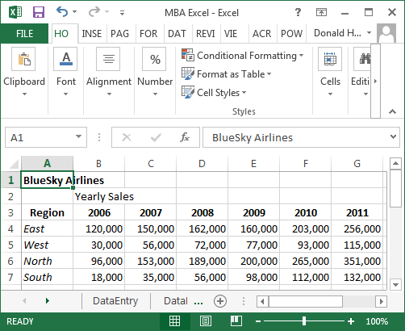

### To spread a label across cells, highlight the range of cells and click Merge and Center button in the alignment section

* + Merge and center Blue Sky Airlines across cells A1 to G1, then change to Bold
  + Merge and center Yearly Sales across cells B2 to G2

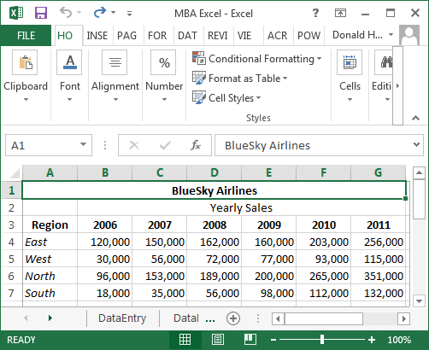

**Calculations and Formulas**

* Highlight the four sales values for 2004. Notice at the bottom of the page, it calculates the average, count and sum of the values.

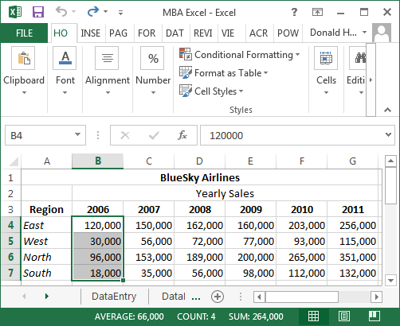

* Next, we’ll enter a formula in the spreadsheet to automatically calculate averages and sums
* In cell A9, type the word Average; also enter Average in I3
* In cell A10, type the word Sum; also enter Sum in J3
* To calculate a formula, use the equal sign, the name of the formula, and the data range
  + In cell B9, enter =average(b4:b7)
  + In cell B10, enter =sum(b4:b7)
  + In cell I4, enter =average(b4:g4)
  + In cell J4, enter =sum(b4:g4)
* Notice that after you type the equals sign and part of the formula name, it gives you several options that start with the same spelling; you can click on the one you want, then highlight the range of data

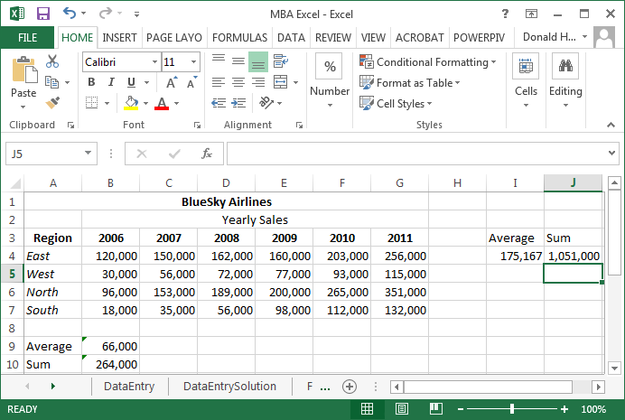

**Copy and Paste**

* Copy and paste works the same in Excel as in Microsoft Word, but you can also copy and paste formulas and Excel will automatically update formulas
* Copy the average and sum formulas across all columns and rows
  + Click on cell B9, click on the copy button in the Clipboard section (or use control-C), highlight cells C9 to G9, and click the paste button in Clipboard
  + Copy cell B10 across for the columns in the same way
  + You can copy several formulas at once. Highlight cells I4 and J4. Click on copy, then highlight the range I5 to J7, and click paste.
  + Look at the formulas in B9 and C9. How are they different?

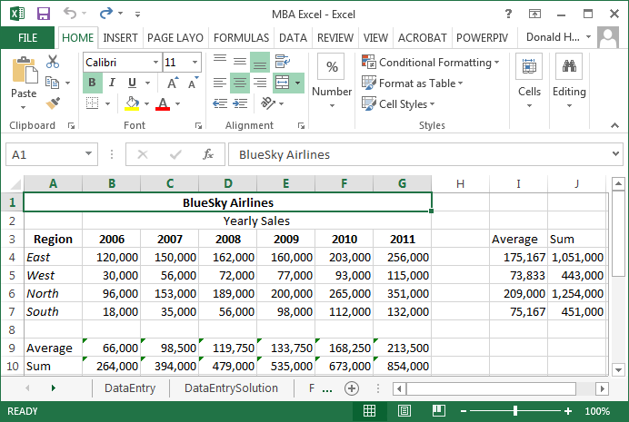

**Checking Formulas**

* Excel has an auditing feature to check formulas; click on the tab labeled Formulas
* Click on B9, then click on Trace Precedents in Formula Auditing
* To clear the arrows, click on Remove Arrows

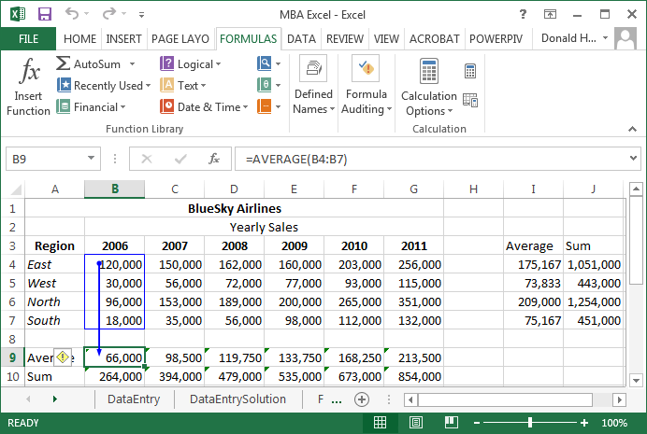

**Graphing Data**

* Sometimes you might want to graph your data. Excel can graph columns and rows of data, but has difficulty if anything is in the upper left corner. First, delete the word Region by clicking on cell A3 and pressing the delete key.
* Highlight the data by clicking on the cell labeled A3 through G7.
* Next click on the Insert tab at the top of the screen.
* In the section labeled Charts, click on the tiny icon in the lower right corner of charts to bring up the possible chart options.
* Move the cursor over each options and select the 3-D column chart, click OK

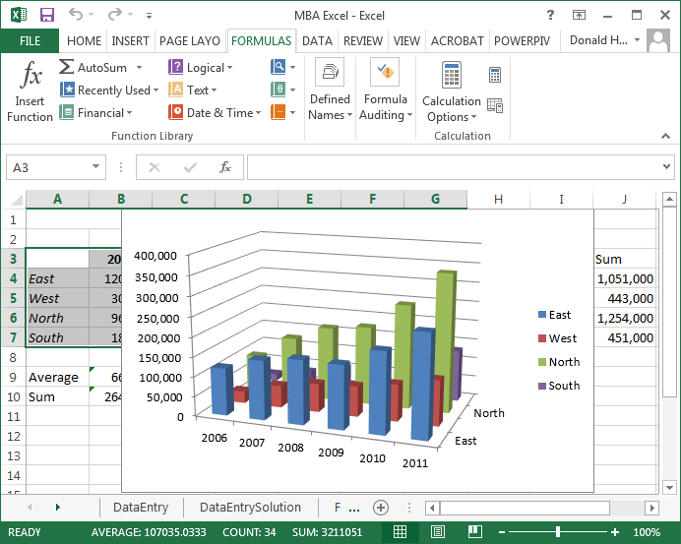

* Let’s move the chart to another sheet. Click on the upper right corner of Excel, select Move Chart Location, click on New Sheet, then OK.
* At the top of the screen click on Chart Tools: Design: Type, Change Chart Type to change the type of chart
* In the Chart Tools: Design: Data, click on Switch Row/Column. What happens?
* In the Chart Tools: Design: Chart Layouts, there are several options (scroll down). How are they different?
* Next, try Chart Tools: Layout. Experiment with Labels and Axes. Under 3-D Rotation, change the X and Y rotation.

**Saving your Spreadsheet**

To save a spreadsheet, click on File at the upper left corner of the screen, move the cursor over Save As. You’ll notice that you can save your Spreadsheet in a variety of formats.

**Microsoft Excel: Sorts, Filters, Pivot Tables**

**Sorting Data**

* Use the SortData spreadsheet for this exercise.

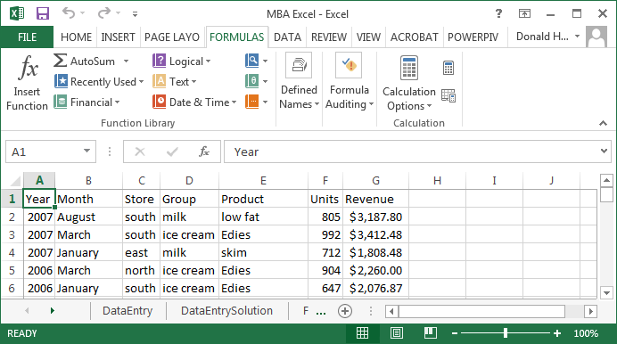

* To sort data, highlight the top of the columns (A through G). The entire columns should be highlighted.
* Click on the Data tab at the top of the spreadsheet.
* Click on Sort; note that “My data has headers” is checked. Why is it checked?
* Select the first sort criteria: Store
* Click on Add Level, then add the second sort criteria: Group

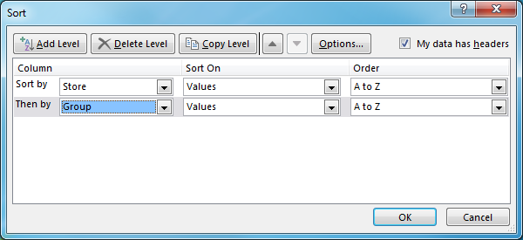

* Click OK, and the data is sorted
* How would you sort from Z to A (reverse alphabetical order)? Why would you want to sort in a different order?

**Filters**

* Use the FilterData spreadsheet for this exercise
* A filter allows you to select specific data out of a long list
* First, click on cell A1, then click on the Data tab, then Filter (looks like a funnel)

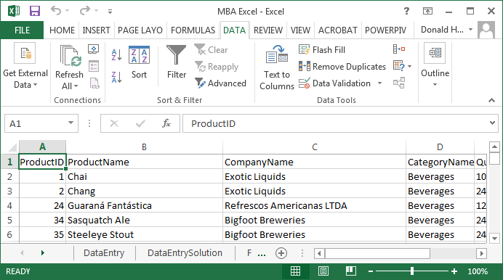

* Notice that there are drop down arrows for each column. Let’s find all products which Exotic Liquids produces.
* Click on the drop down arrow next to company name; uncheck “(Select All)”, then check Exotic Liquids and OK. What happens?

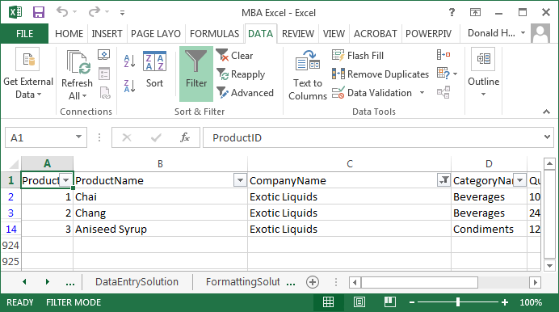

* Go back and click Select All for Company Name
* To find which products have a price greater than 50, click on the down arrow next to unit price, Number Filters, Greater Than, enter 50 in the field, and click OK
* You can turn on multiple filters. Add a filter for Category Name equal to Meat/Poultry to see which Meat/Poultry products cost more than 50

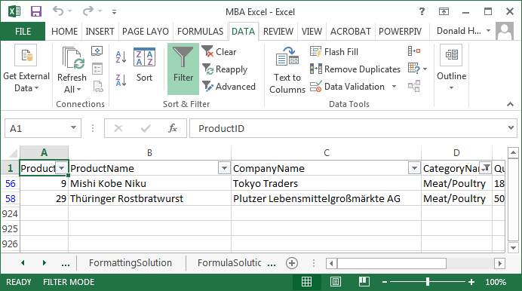

* To turn off the filter, click on the Filter icon and the drop down arrows should disappear.

**Pivot Tables and Charts**

Pivot tables and charts are powerful techniques to quickly summarize and display large amounts of data. For this example, use the PivotData spreadsheet.

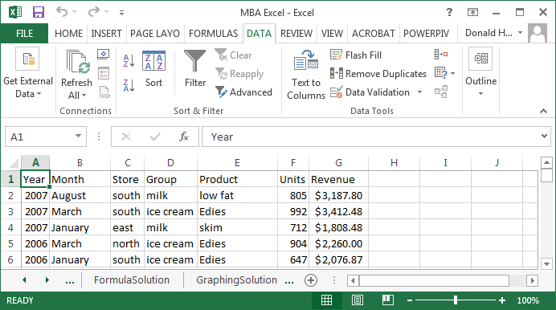

1. The headings must be in the first row of your data.
2. Click anywhere in the data table.
3. Click on the Insert tab.
4. Click on PivotTable; it should automatically highlight the entire table.
5. Make sure New Worksheet is checked, then click OK.

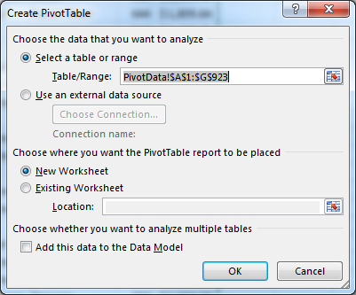

1. In the pivot table dialog box, we want to add row labels, column labels, and identify what goes into the table.
2. For this example, let’s build a table with store revenue by year. First click on store and drag it to the row label. These will become the row labels on the left side of your table.
3. Next, click on year and drag it to the column label. These will become the column labels at the top of your table.
4. Finally, click on revenue and drag it to the values cell. These values will feed the interior of the table. The default function is Sum. If you want to change this function, click on the down arrow in the values box, then select the function (average, min, max, etc.)

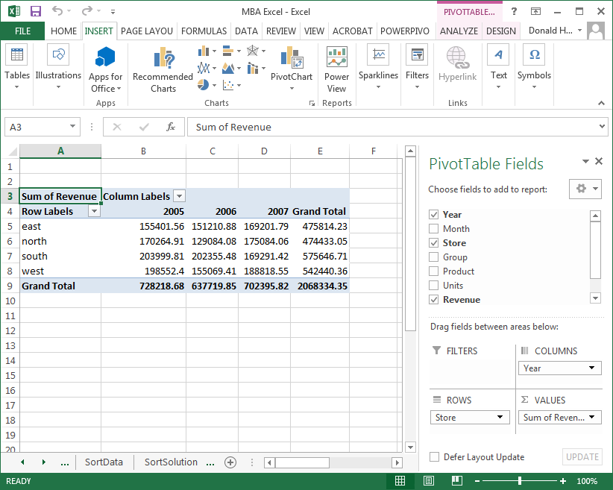

Add group to the row labels to see what happens.

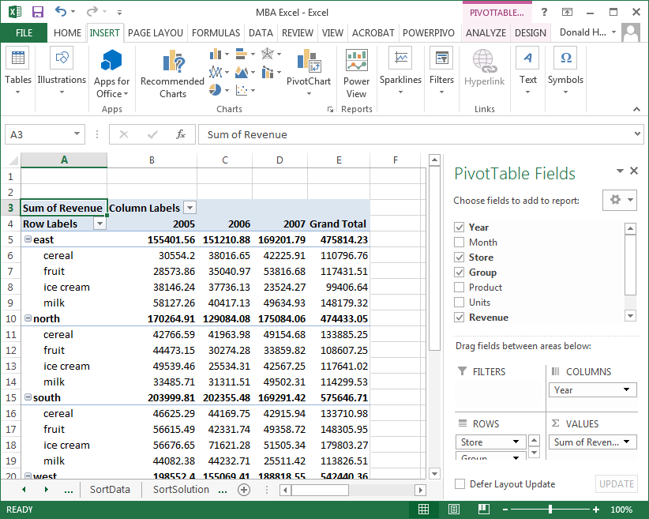

Let’s now create a Pivot Chart. The steps are:

1. Uncheck Group to simplify the data.
2. Click anywhere inside your Pivot Table. An Options tab will appear. Click on Pivot Chart.
3. A chart dialog box will appear. Click on your preferred type of chart.

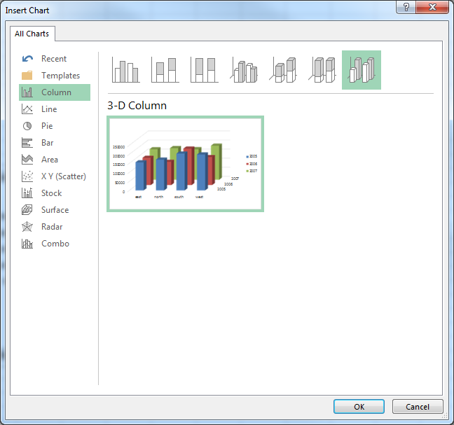

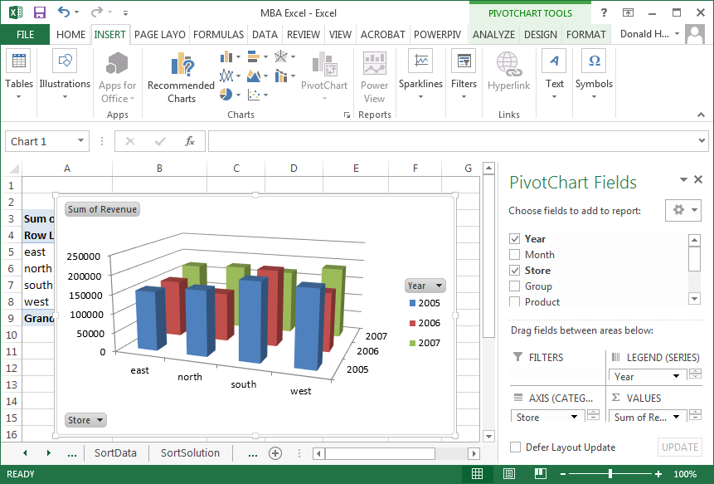

To move the chart to its own page:

1. Right click on the picture
2. Click on Move Chart
3. Select New Sheet and name the new sheet

**Microsoft Excel 2016: PowerView**

**PowerView Add-in**

The PowerView options are available as an add-in to Excel 2016. The steps to add it are:

1. In Excel 2016, click on the File tab, then Options, then Customize Ribbon
2. Under Main Tabs, click on Insert, then click on New Group
3. Under Choose commands from, click Commands Not in the Ribbon, then select Insert a Power View Report
4. With both Insert a Power View Report and New Group (custom) selected, click Add, then move the New Group (custom) to where you want it on the ribbon
5. Click New Group (custom), then Rename, then in the Display Name box, type Reports or the name you want
6. Click OK twice
7. The first time you insert a Power View sheet, you might be prompted to enable the Power View add-in. Click Enable.

PowerView allows you to quickly generate business analytics graphs of complex data. PowerView is only available in Microsoft Excel 2013 or higher. Click on the PowerView spreadsheet for this exercise. This data is a list of international alumni from the Whitman School.

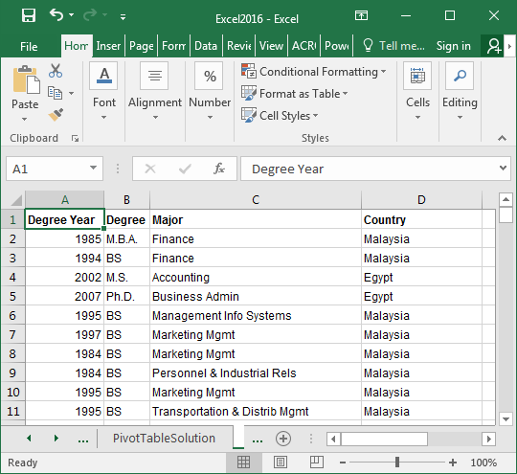

To generate a PowerView report:

1. Click on the Insert tab at the top of the screen
2. In the Reports section, click on Power View
3. In the Insert Power View screen, click OK.

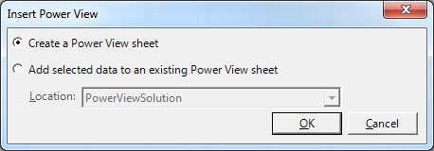

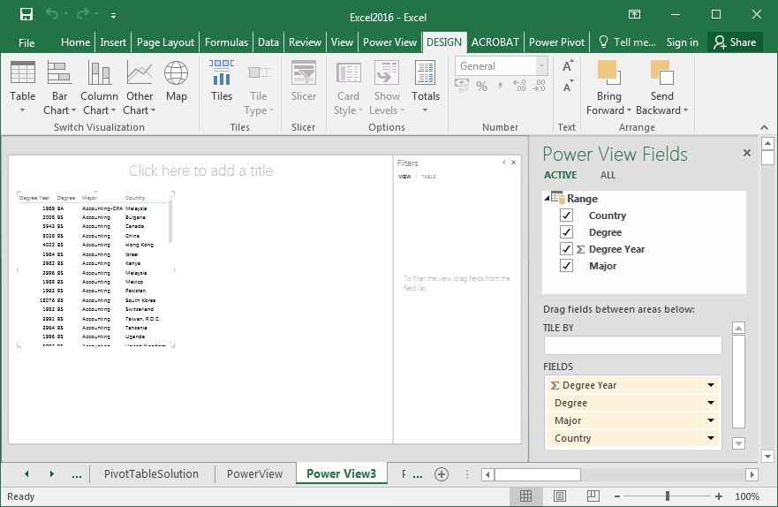

On the left side of the screen is your data. On the right side are the data fields or column labels (country, degree, degree year, major).

To create a map of degrees by country:

1. Uncheck Degree Year; uncheck Major
2. Click on the Map icon in the upper left portion of your screen

Now we have a picture, but no data. Notice that in the field labeled ∑ SIZE has no field entered. This field determines the data to be displayed. Drag Degree from Power View Fields to ∑ SIZE.

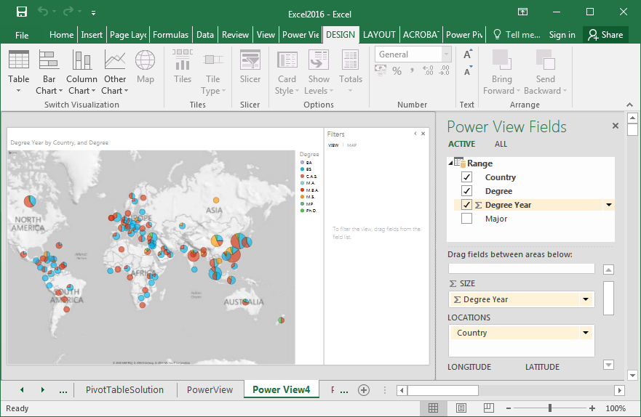

Be sure to have the following on the right side of the screen:

1. Drag Degree to ∑ SIZE; it should show # Count of Degree
2. LOCATIONS should have Country
3. COLOR should have Degree

Put your cursor over a country’s pie chart. By moving the cursor over different parts of the pie chart, it will give you the data associated with each pie segment.

You can also filter data to limit the data displayed on the screen. To activate a filter:

1. Click on the funnel to the upper right of the map.
2. In the Filters arrow to the right of the map, click on the arrow next to Degree
3. A list of degrees should appear. Check the degrees BS, MBA, MS and PhD
4. To reset to all degrees, click on All

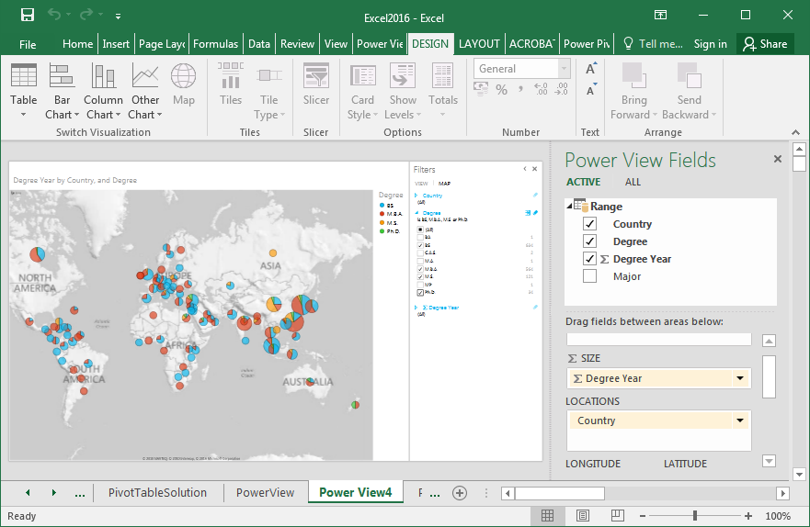

To add an additional layer of analysis, drag Major to Vertical Multiples.

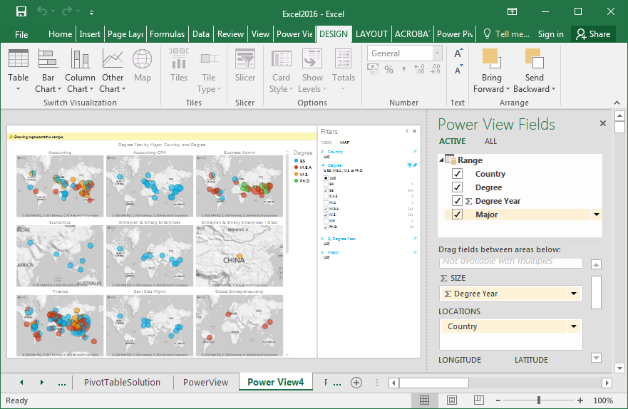

Drag it to Horizontal Multiples.

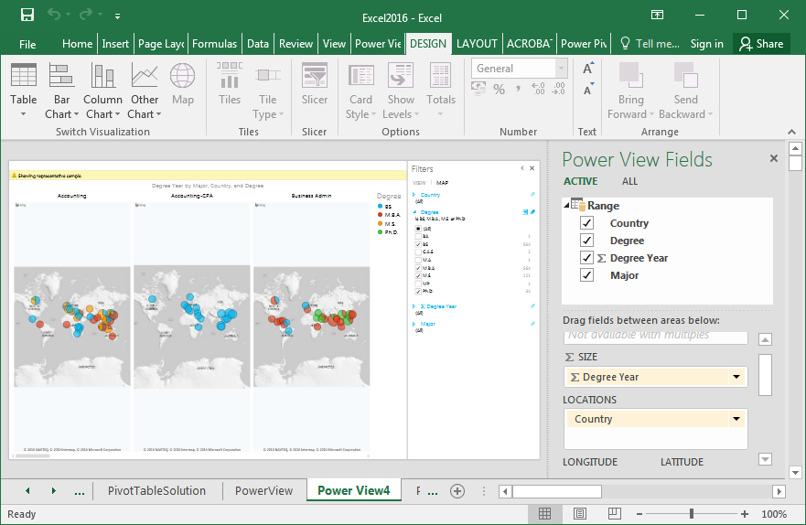

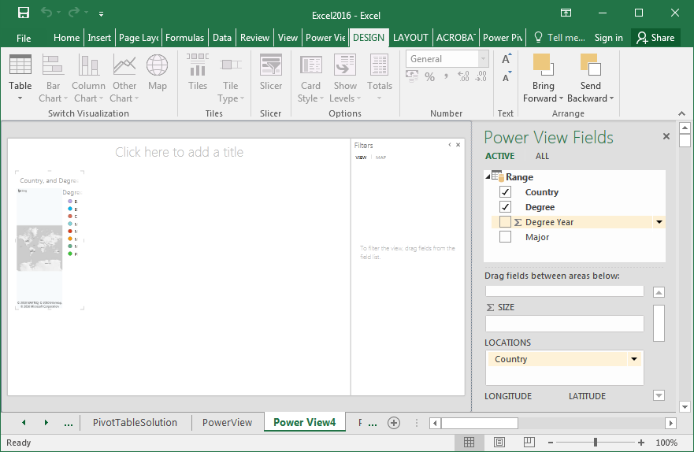

The map on the left is not very clear.

1. Move your cursor over the map.
2. An arrow in the upper right of the picture should appear.
3. Move the cursor over the arrow; it should say Pop out.
4. Click on the arrow.

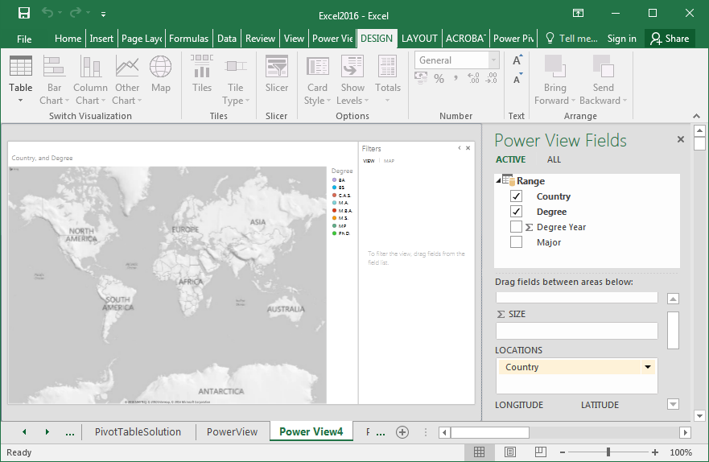

**Microsoft Excel: Financial Tools**

**Net present value**

Net present value is used in finance to determine a value of a future stream of money in today’s dollars. Net present value determines what a revenue stream would be worth in today’s dollars. There are two NPV functions: NPV calculates the net present value of a stream of money at regular intervals; XNPV calculates the NPV of a stream of money at irregular intervals.

NPV(rate, range of cells)

XNPV(rate, values, dates)

The NPV calculation assumes that all cash flow is at the end of the period.

In the example below (NPV spreadsheet), investments are entered as negative numbers, returns as positive. Calculate the NPV for Options 1, 2 and 3 and enter the formulas in cells C3, D3, E3.

1. To calculate the NPV of Option 1, in cell C3, enter the formula for NPV.
2. For rate, refer to cell G4
3. For range of cells, highlight the investment and returns (cells C4:C20)
4. Similarly, calculate the NPV for Options 2 and 3

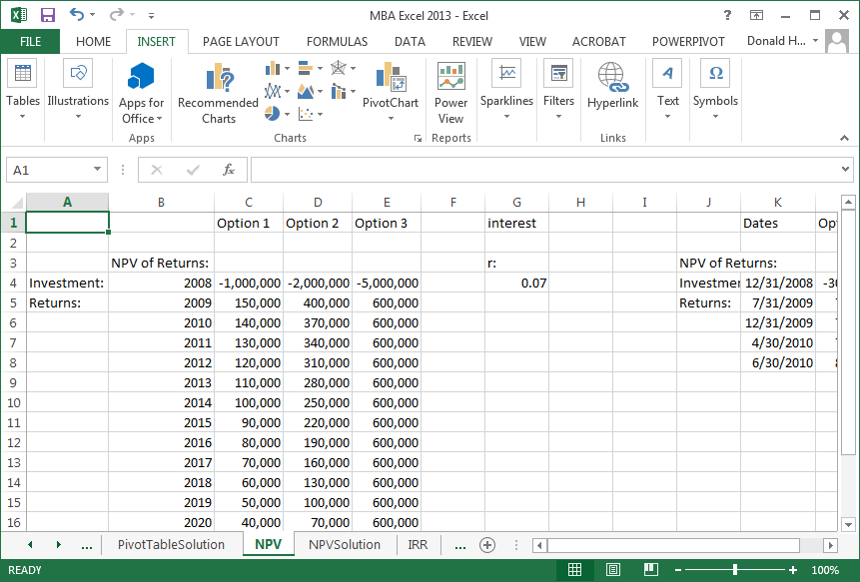

Now calculate the NPV of Option 4 using the XNPV formula and enter it in cell L3.

**Internal rate of return**

The internal rate of return (IRR) calculates what the interest rate would have to be so that the NPV is zero. In some situations, there is no IRR. The spreadsheet is set up similar to the NPV problem, but investments are listed as negative returns. The function for IRR is:

IRR(data range)

The IRR spreadsheet gives an example of three investment options, revenue streams, and the calculated IRR. A corporation would compare the IRR to the possible returns available elsewhere to determine if a project was worthwhile.

In cell B2, enter the formula for IRR of Option 1. Similarly, calculate the IRR for Options 2 and 3 in cells C2 and D2.

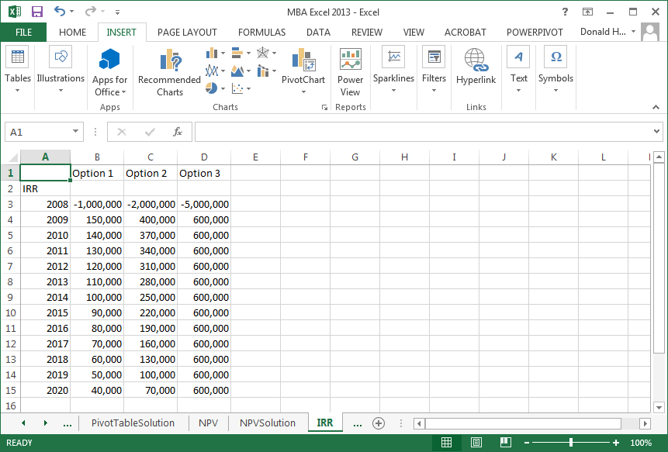

**Microsoft Excel: Statistics**

**Data Analysis Add-in**

The statistics options are available as an add-in to Excel. The steps to add it are:

1. In Excel, click on the File tab, then Options
2. Click on Add-Ins
3. Click Analysis TookPak Add-in, then Go
4. Check the box for Analysis ToolPak, then OK

**Data Analysis: Descriptive statistics**

Use the DescriptiveStatistics spreadsheet tab for this exercise.

There are a number of descriptive statistics that can be automatically generated, including:

* Mean: arithmetic average
* Median: middle point in distribution
* Mode: most common value (highest frequency of occurrence)
* Kurtosis: is the data peaked higher or lower than normal?
* Skewness; is the peak shifted left or right?
* Standard deviation: measure of spread
* Range: highest value minus lowest value

To calculate the descriptive statistics:

1. Click on the data tab, then data analysis, descriptive statistics, and OK.
2. Enter the input range for the IQ data; if you include the header, click on Labels in first row.
3. Check Summary Statistics, then OK

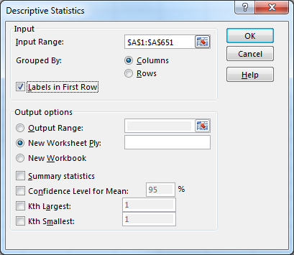

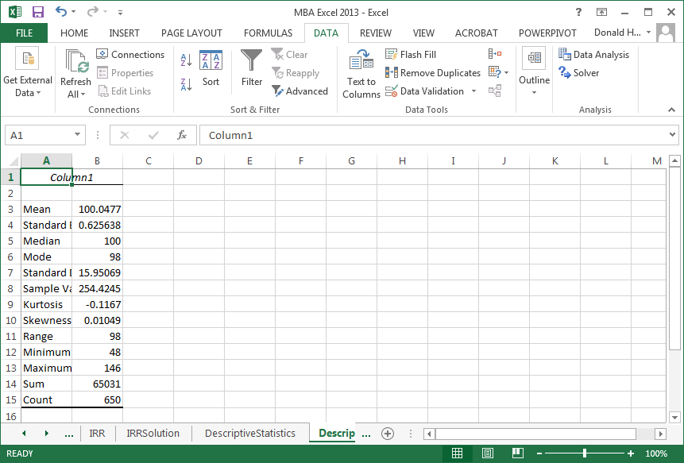

**Correlations**

Correlation analysis identifies how two or more variables are related. For this exercise, use the Correlation spreadsheet. This spreadsheet records the upward or downward movement of stock by month.

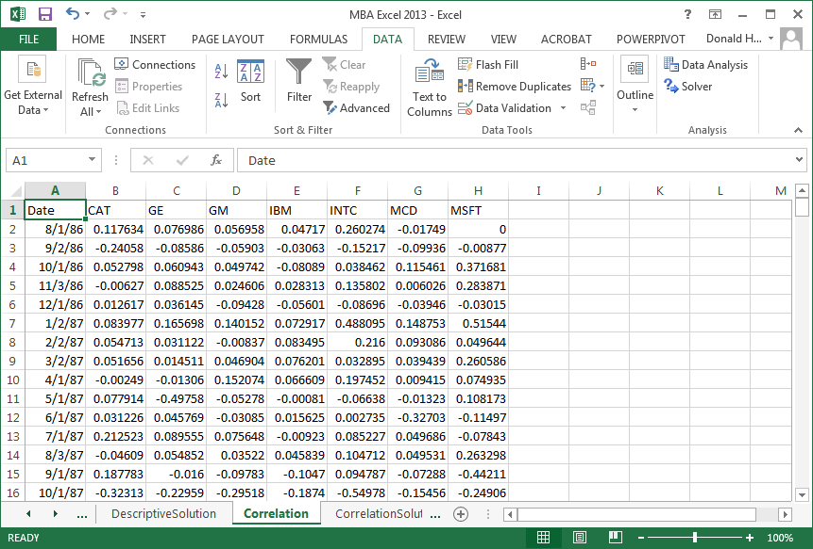

The stocks listed are Caterpillar, General Electric, General Motors, IBM, Intel, McDonalds and Microsoft. Click on the data tab, data analysis, correlation, then OK. Highlight all data, group by columns, check Labels in First Row, then OK.

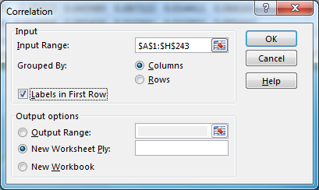

The result is shown below. A positive correlation means that when one variable increases, the other increases. A negative correlation means that when one increases, the other decreases.

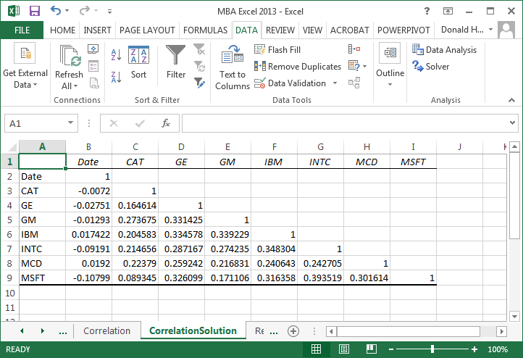

**Regression Assumptions**

Regression is a technique that attempts to measure the relationship between and outcome variable (dependent) and explanatory variables (independent). To use linear regression, there are three key assumptions

1. relationship between x and y is linear
2. the x’s are fixed numbers, not random variables (non-stochastic), not related to each other, i.e., independent: Corr(Xi,Xj)=0
3. the error terms:
   1. have zero mean and constant variance: E(εi) = 0, V(εi) = σ2
   2. the error terms are independent: Cov(εi,εj) = 0
   3. the error terms are normally distributed ~N(0,σ2)

Violation of these assumptions requires the use of more sophisticated techniques.

**Straight line relationships**

When you want to determine if there is a straight line relationship in statistics, you can run a regression. Excel has the ability to perform regression analysis. For example, if you wanted to model the relationship between items produced and factory costs, you could estimate the linear relationship. Units produced would be called the independent variable; production costs would be the dependent variable. The output, costs, depends on the input, number of units produced.

For this example, use the Regression spreadsheet.

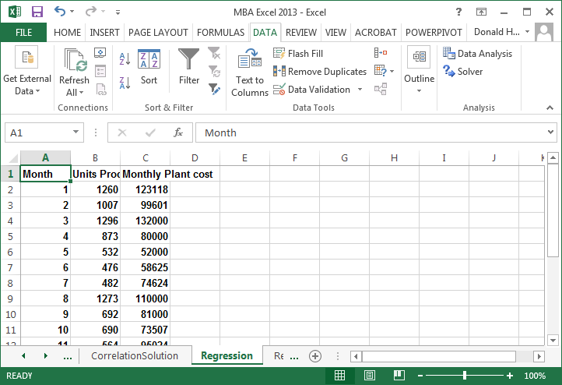

Let’s first draw a scatterplot to see what the data looks like.

1. Click on the Insert tab
2. Highlight the the cells b1:c15
3. Click on Scatter in the charts group.

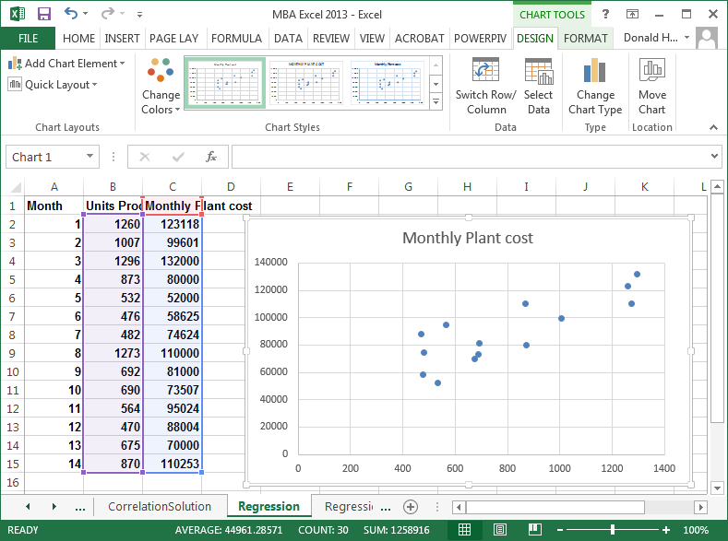

Reviewing the chart, it appears that there is a linear relationship. We will therefore perform a linear regression. Click on any data point, right click, then add trendline.

In the Format Trendline, Trendline Options, select Linear, then check the boxes for Display Equation and Display R-squared value.

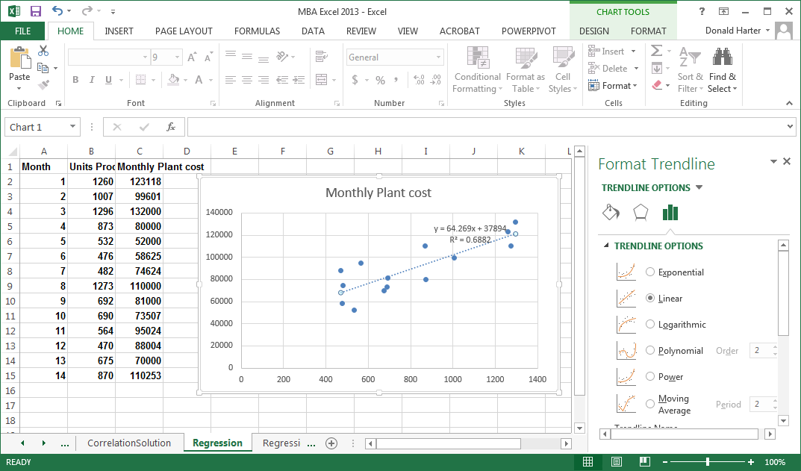

In the picture above, the coefficient on x is approximately 64. This means that as unit production increases by one, costs increase by $64. What does the number 37,894 represent? What does the R2 = 0.6882 mean?

**Exponential growth**

Some data relationships are not linear, but grow at an increasing rate. These curves often follow the exponential growth curve. An exponential growth curve will have the same percentage growth per period compounded over time. Use the Exponential spreadsheet.

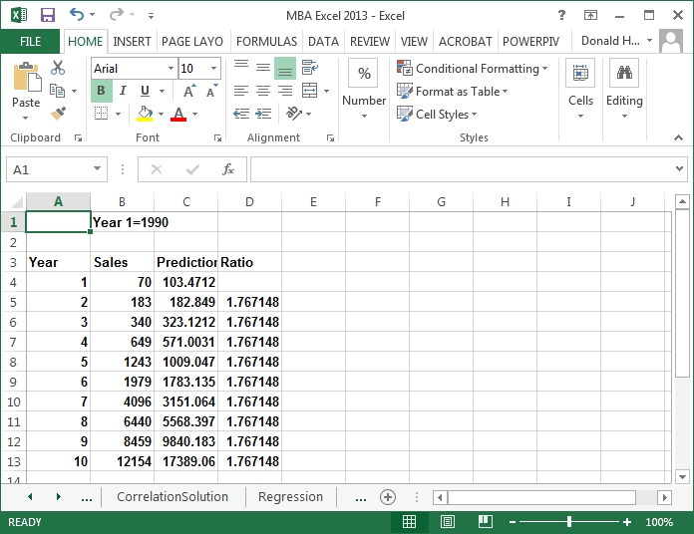

Let’s first draw a scatterplot to see what the data looks like.

1. Click on the Insert tab
2. Highlight the the cells a3:b13
3. Click on Scatter in the charts group.

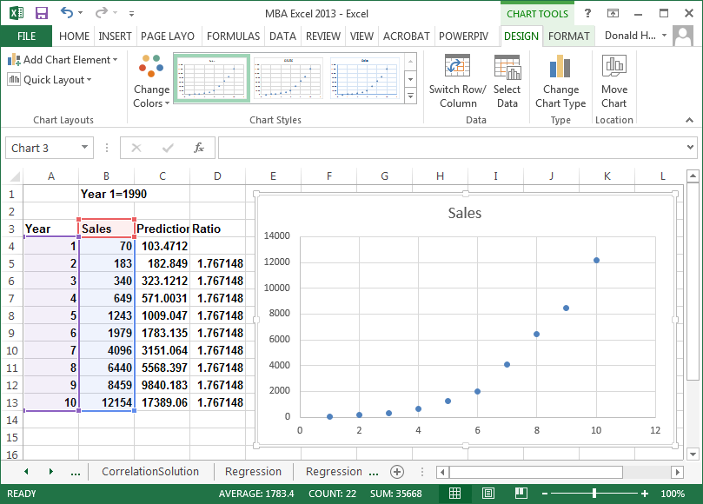

This data definitely does not look linear. So let’s use the exponential curve. Click on any data point, right click, then add trendline. Select exponential, display equation and display R-squared, then Close.

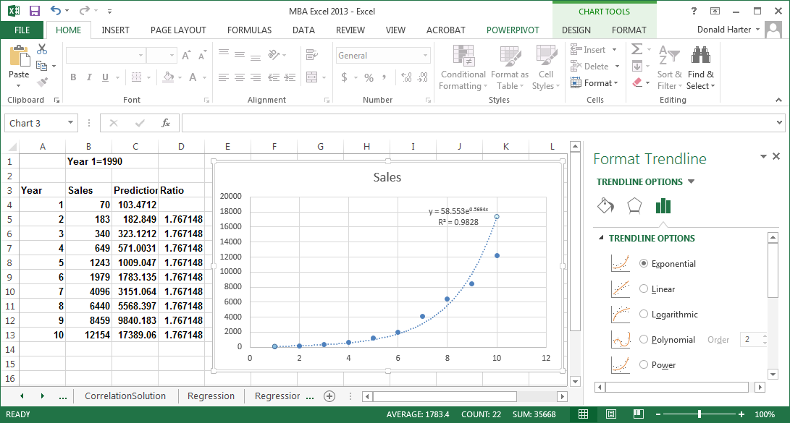

**Power curve**

The power curve allows you to examine economies of scale and diseconomies of scale. Economies of scale means that you become more efficient as volume increases. Diseconomies of scale means that you become less efficient as volume increases. Use the Power spreadsheet.

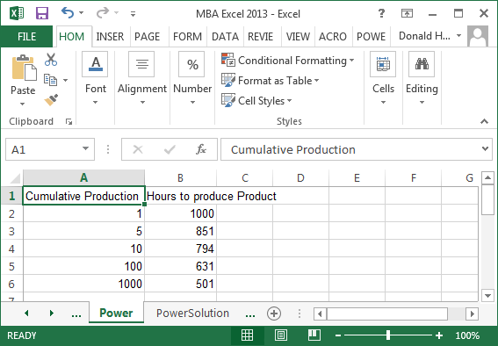

Let’s graph as before. Click on Insert, Scatter.

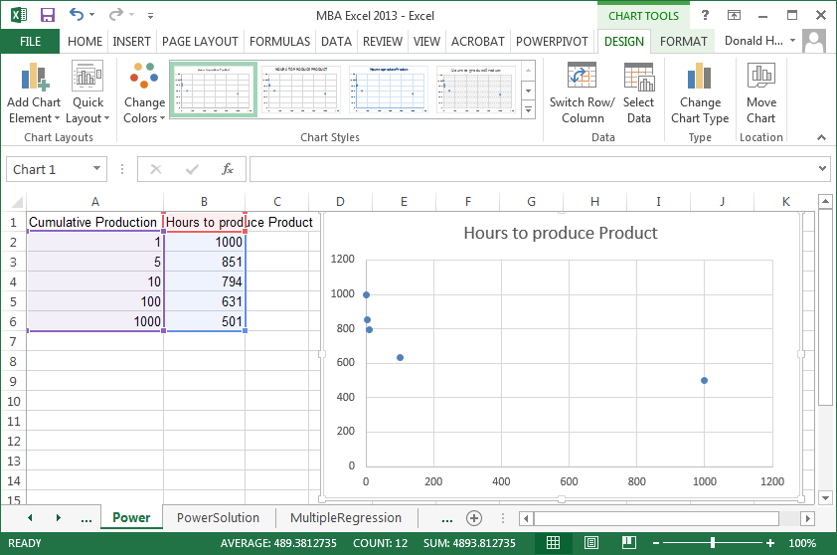

Now click on any data point in the graph, right click, add trendline. Click on Power, display equation, display R-squared.

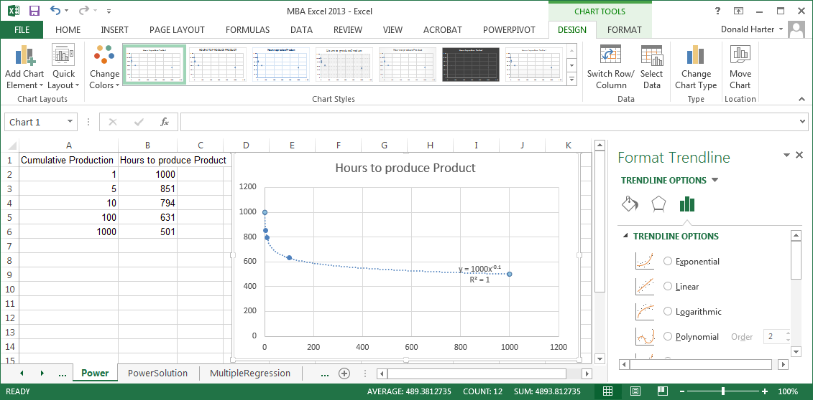

**Multiple regression**

When we reviewed linear regression earlier, we only had one independent variable. Multiple regression includes several independent variables. Use the Multiple Regression spreadsheet.

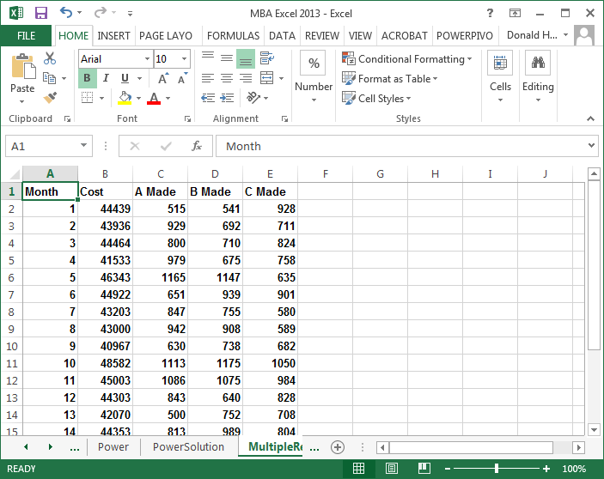

To run a multiple regression:

1. Click on the data tab, data analysis, regression, then OK.
2. For the Y-range, highlight the values in the B column for cost
3. For the X-range, highlight the values in the C, D, and E columns.
4. If you included the headings at the top of the columns, click labels.

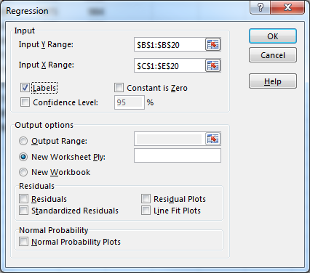

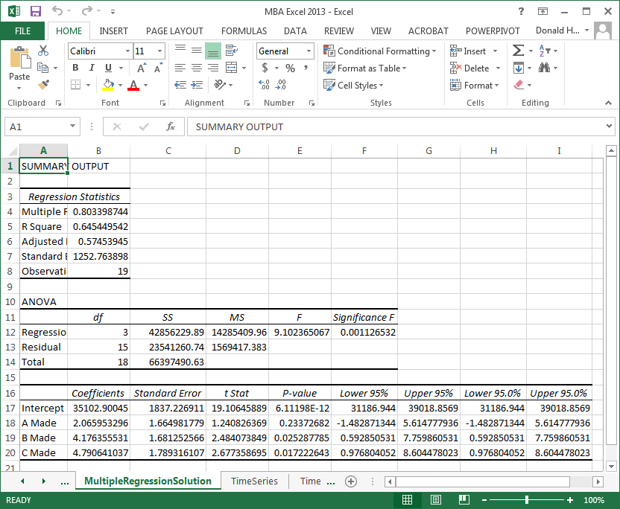

**Time series**

Time series problems have data where one data point is dependent on the previous data point. For example, the closing price of Microsoft stock can be tracked day by day. Today’s price is dependent on yesterday’s price. This dependency from one day to the next, or one time period to the next, is a characteristic of time series data.

Often there is so much variation in time series data that it’s hard to see trends. Seasonality also masks a trend. Seasonality is variations in data due to high or low points that occur at regular intervals. Create a scatter plot for the Amazon data using the Time Series spreadsheet. For this scatter plot, select the option to connect the dots.

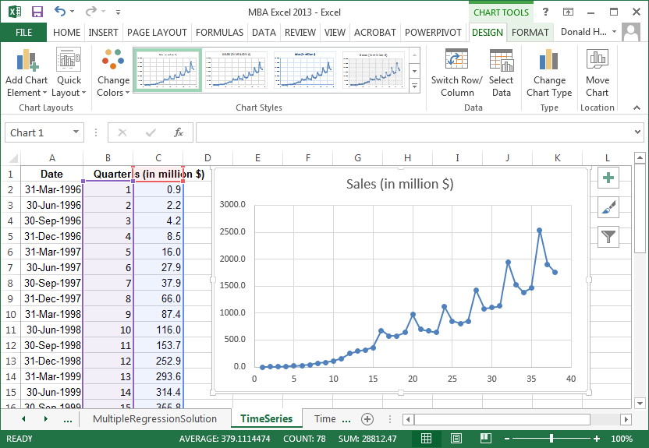

Notice that there is seasonality in the data. Amazon sales tend to peak during the fourth quarter of each year due to holiday sales. However, this seasonality masks the true trend. A moving average helps to see the trend.

To add a moving average line, follow these steps:

1. Right click on a data point.
2. Click on Add Trendline
3. Click the checkbox for moving average. Since we have quarterly data, let’s identify the number of periods as four.

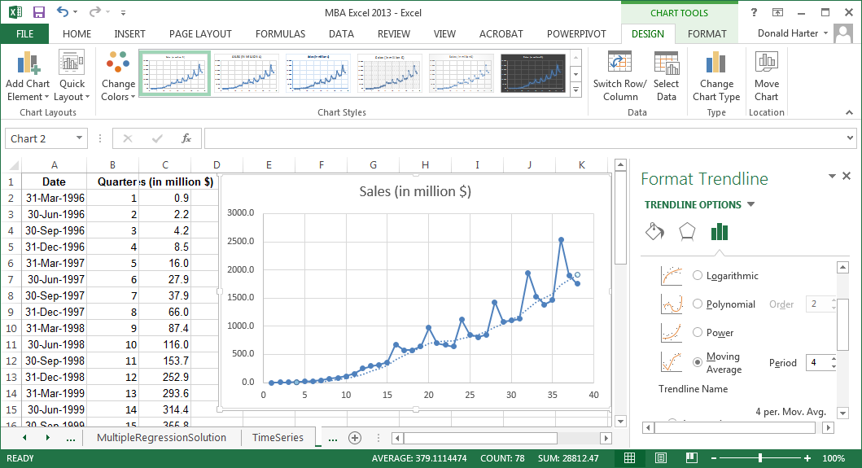

The moving average line is superimposed on the graph. It’s now very clear what the trend looks like when a moving average accounts for seasonality.

**Microsoft Excel:**

**Sensitivity Analysis & Conditional Formatting**

**Sensitivity Analysis**

Sensitivity analysis allows you to see the effect of a changing variable on an outcome variable. In the example below, use the spreadsheet tab Sensitivity.

The spreadsheet provides the demand curve, costs, revenue and profit for a widget. By changing the price, you can observe the effect on sales and profitability. But this approach only allows you to look at one price at a time. Using the Sensitivity spreadsheet, we will build the spreadsheet shown in the diagram below.

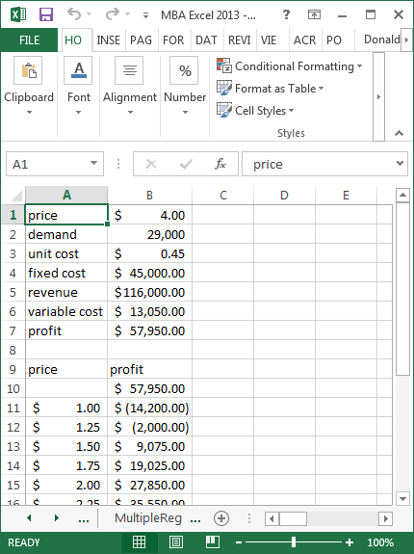

The following steps build a table to examine the effect price has on profits, revenue and costs.

1. To set up a one-way table, enter the labels of your one input variable and all of the output variables in a row. In this example, enter price in A9 and profit in B9.
2. Next, enter a column of prices under price **but skip the first cell below the word price**. In this example, enter a column for price with price ranging from $1 to $4 by $0.25 increments.
3. Immediately under profit in cell B10, enter =B7, so the profit calculation is filled in.
4. Finally, we will create a data table. Highlight the fields immediately under the labels and continue until all of the prices are highlighted. In this case, we highlight A10:B23. Click on the Data tab at the top of the page, click on What-If Analysis, Data Table, then enter in the column input cell the cell reference for variable that you want to vary (i.e., B1, which is price), then click OK. This should populate the data table.

What you really did: The price column represents on which prices you would like to perform a what-if analysis, and the three formulas are the outcomes that you want to analyze when price changes. The first step was to set up the price points and the formulas. When you created the data table, you identified what variable changes, but used an absolute address.

If you want to change two variables at once, we create a two-way table. In this example, let’s change both price and unit cost for our widgets. The result that we want will look like the picture below.

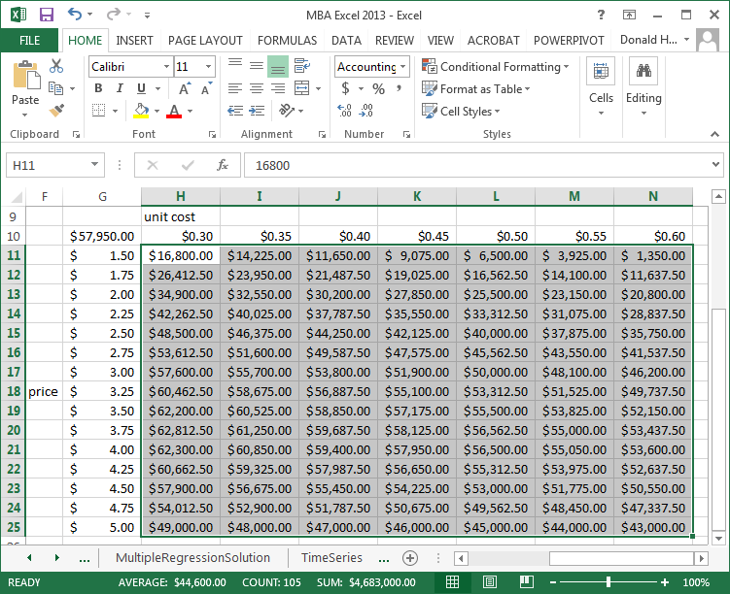

Note that in a two-way table, you can only have one outcome variable. In this case, let’s use profit as the outcome variable. The following steps create a two-way what-if analysis:

1. As before, enter a column for prices. In the picture, the prices are in cells G11:G23. You can type a label of price to the left of any cell.
2. Enter variable costs in H10:N10 from $.30 to $.60 in increments of $.05. You can enter a label for variable costs above the first entry (cell H9).
3. The price column and variable cost row will form the boundary of the table.
4. Now enter the formula that you want to calculate where the column and row intersect, in this case, cell G10. The formula we want to use is for profit; since we have a named field for profit, enter =profit.
5. Now highlight the entire table of prices and variable costs G10:N25. Click on the Data tab at the top of the spreadsheet, then What-if Analysis and Data Table. Since the variable that we are varying across the row is unit cost, and unit cost is a named variable, enter unit cost for the row variable. Likewise, since price varies down the column and is named variable, enter price as the column variable. Click OK.

**Conditional formatting**

Conditional formatting allows you to display data differently based on the values of the data. For example, you can change the font color, background color, or other characteristics to make the data jump out at you when it satisfies certain conditions. Let’s convert the data in the Sensitivity spreadsheet to something more visual.

1. Continuing to use the Sensitivity data, highlight cells H11:N25.
2. Click on the Home tab, Conditional Formatting, Color Scales, then select a color scheme from the right.

For the next example, use the Global Warming spreadsheet. In the column labeled “top ten red…”, we will use conditional formatting to change the background based on the values in the column. To do this, use the following steps:

1. Highlight the values B3:B152
2. Click on the Home tab at the top of your spreadsheet.
3. Click on Conditional Formatting, Top/Bottom Rules, Top 10. Note that in the next screen, you can change top 10 to top anything. Select red as the color, then OK.
4. Click on Conditional Formatting a second time, Top/Bottom rules, Bottom 10. Change the font and background color to match the column heading.
5. For the next column, use the same approach but select the top and bottom 10%.
6. For the last column, use the same approach but select above and below average.

A feature of Excel is data bars to enhance data display. Data bars, color scales and icon sets can be used to enhance tabular data. Using the spreadsheet Experience, the steps to implement these new features are listed below.

1. Select the range of values under the title students.
2. Click on Conditional Formatting.
3. First try Data Bars, and place your cursor over the options that appear on the right.
4. Next try Color Scales, placing your cursor over the options on the right.
5. Finally try Icon Sets, again placing your cursor over the options listed.
6. For each of these features, you can click on more rules and specify additional combinations.

**Example: Buy Response Curve**

**Sample:** For a sample of 173 Whitman School undergraduate students, the following information was recorded in Fall 2012:

1. Gender: 1 if male, 2 if female
2. On a 1-7 scale (1: not interested at all, 7: very interested), how interested is the student in buying an exhibition basketball game between Miami Heat and Los Angeles Lakers at the Carrier Dome at each of the following prices: $20, $25, …, $80. For example, game20 is interest level at $20, game25 is interest level at $25, etc.

**Creating Demand Curves**

At a given price such as $25, we assume that the student will buy the ticket if interest is 5, 6, or 7 on the 1-7 scale. Thus, demand at that price is how many students in the sample select 5, 6, 7 at that price.

**Demand for all students, QALL (men and women combined)**

* Click on cell A1, then click on Data tab, then Filter.
* Click on drop down arrow next to game20; uncheck “select all,” check 5, 6, and 7.
* Click OK
* Click on cell C above game20. You will get the number of cases where interest at a price of $20 is 5, 6, or 7. This is the estimate of demand at a price of $20. Repeat for $25, …, $80.

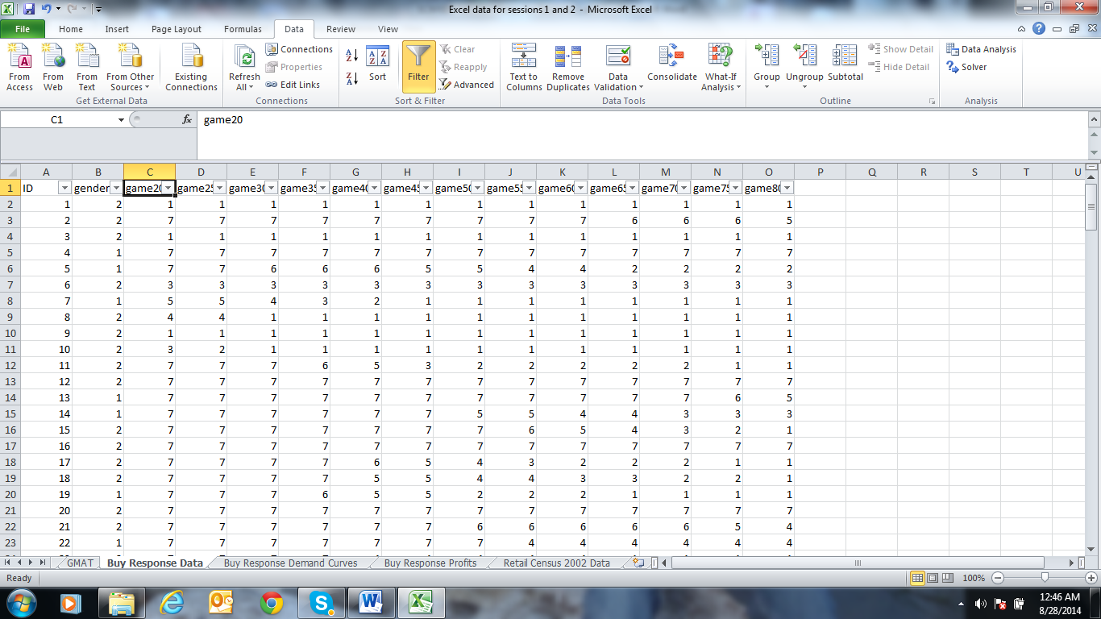

**Demand for men only (QMEN)**

* Click on cell A1, then click on Data tab, then Filter.
* Click on drop down arrow next to gender, uncheck “select all,” and check 1.
* Click on drop down arrow next to game20; uncheck “select all,” check 5, 6, and 7.
* Click OK
* Click on cell C above game20. You will get the number of cases where interest at a price of $20 is 5, 6, or 7. This is the estimate of demand at a price of $20. Repeat for $25, …, $80.

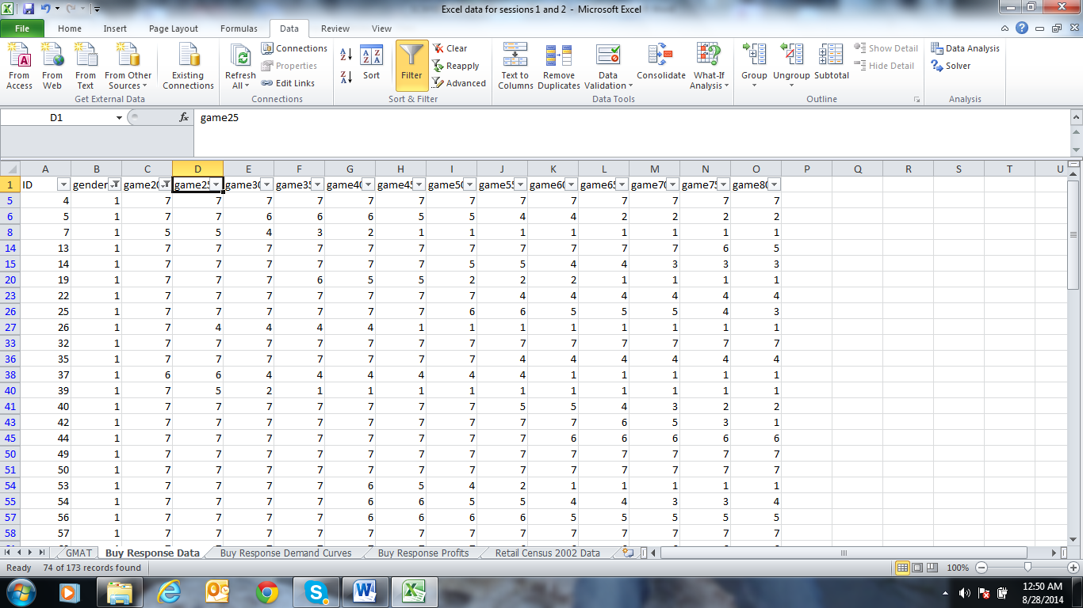

**Demand for Women only (QWOMEN)**

* First use filter to select women (gender = 2)
* Then find demands for the different prices as with men.

**Demand Curves**

* In a new sheet, create a table of price, QALL, QMEN and QWOMEN.
* Using a scatter plot and trend lines, fit the regression model:

QALL = A + B*PRICE

QMEN = A1 + B1*PRICE

QWOMEN = A2 + B2*PRICE

Here, the fitted lines are

QALL = 183.81 – 1.6209*PRICE

QMEN = 88 - .6385*PRICE

QWOMEN = 95.813 - .9842*PRICE

**Profits at different prices:**

* Assume fixed cost = 0 and unit variable cost = 10
* Then, profit = (PRICE – 10)*Demand
* Vary price from $20 to $80 in increments of $1.
* Using What-If analysis, find profits for all students, men only and women only as price varies from $20 to $80.

**Question:**

* What is the profit maximizing price if we have to set the same price for men and women?
* What are profit maximizing prices if we could set different prices for men and women?
* How much more profit do we get if we can set different prices for men and women?

**Selecting a Random Sample**

Open the worksheet called “Retail Census 2002.” This worksheet lists 960 metropolitan and micropolitan areas in the USA ranging from Abbeville, LA, to New York City, NY. For each area, the Excel sheet provides the number of retail establishments in the area, annual revenue (dollar sales) in million dollars, payroll in million dollars, and number of employees. The ID uniquely identifies each area. We will draw a random sample of 10 areas out of 960.

**Generating Random Numbers:**

* In any cell not currently used, say H1, type in = randbetween(1,960), then hit enter. Excel will return a random number between 1 and 960, where each number from 1 to 960 is equally likely to be chosen.
* Click on H1, and type control-C. Copy to 10 cells I1:I10 by marking I1:I10 and typing control-V.
* What happens to the number in H1?
* What numbers do you get in I1:I10?
* Mark I1:I10, type control-C. Then mark click on J1 and type control-V. What do you get in J1:J10? What happens to the numbers in H1, and I1:I10?

**Note:**

* Each time you click control-V, Randbetween selects new random numbers from {1,2,…, 960} even in the cells where you selected a random number before.
* If you wish to keep the numbers you first selected, click on the arrow below “Paste” at the top left of the screen, and click on “Paste Values 123.”

**Selecting the sample:**

* Once you selected the 10 random numbers, note them down and clear the cells by marking the cells with the random numbers and clicking “clear all.”
* Click on A1, then Data, then Filter.
* Click on the drop down arrow next to ID in the first row, uncheck “select all,” and check the ID numbers in your sample. Click OK.
* You have now drawn a random sample of size 10 from the 960 areas.
* This is called a **simple random sample.** In this sampling method, every member of the population is equally likely to be selected, and every combination of ten areas is also equally likely to be selected.